**Assignment -3**

Digital Marketing

|  |  |
| --- | --- |
| Student Name : | Thiru Selvam T |
| Student Roll Number : | 20URCS049 |
| NM ID : | 97C6EB5A9F3EB30ADCB434840EE2B86C |
| College Name : | AAA College of Engineering and Technology |

**QUESTION:**

**Create and design a social media advertisement poster using canva.**

**SOCIAL MEDIA ADVERTISEMENT POSTER USING CANVA:**

**Poster link:** [**https://www.canva.com/design/DAFr9s0e0is/Jt7J1myBh3j-l6SvTWqvXA/edit?utm_content=DAFr9s0e0is&utm_campaign=designshare&utm_medium=link2&utm_source=sharebutton**](https://www.canva.com/design/DAFr9s0e0is/Jt7J1myBh3j-l6SvTWqvXA/edit?utm_content=DAFr9s0e0is&utm_campaign=designshare&utm_medium=link2&utm_source=sharebutton)

**Poster Title: Luffy Crackers**

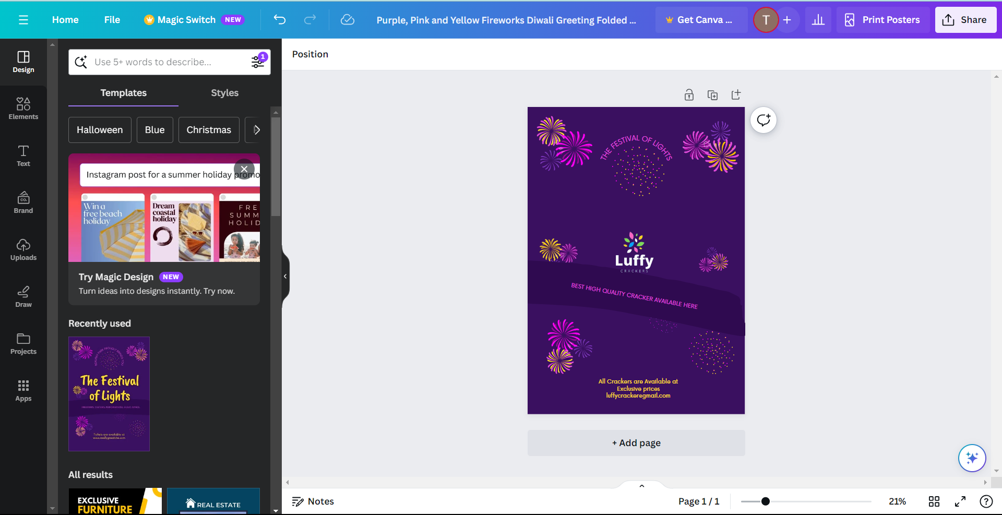

**Poster :**

